ASSIGNMENT:-6

Using Special Operators in Conditions.

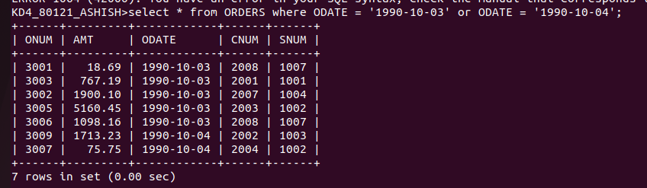
1) Write two different queries than would produce all Orders taken on October 3rd or 4th,1990.

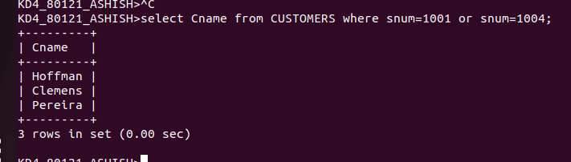
2)Write a queery that selects all the of the Customers serviced by Peel or Motika. (Hint: the snum field relates the two tables to one another).

3)Write a queery that will produce all the customers whose name begin with with a letter from ‘A’ to ‘G’

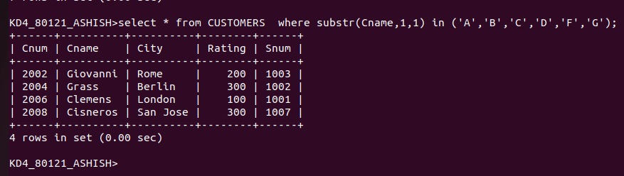
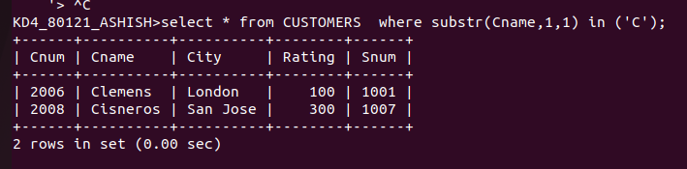
4) Write a query that selects all customers whose names begin with the letter ‘C’.

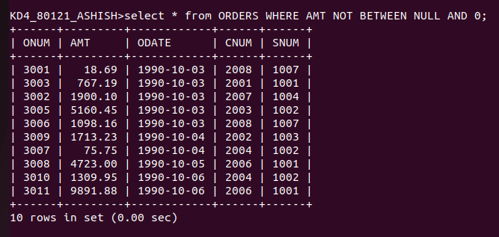
5) Write a query that select all orders except those with zeroes or NULLS in the amt field.

